Title: Vulnerability Assessment and Penetration Testing (VAPT) Report

Name: Vaibhav Tripathi
Task: Week 2 VAPT
Tools Used: Nmap, Nikto, Metasploit
Date: 27/03/2026

Introduction

Vulnerability Assessment and Penetration Testing (VAPT) is a security testing process used to identify, analyze, and mitigate vulnerabilities in systems and applications. It combines automated scanning with manual exploitation techniques to evaluate system security.

In this project, a complete VAPT cycle was performed on a vulnerable system (Metasploitable2) using Kali Linux as the attacker machine.

Objective

The objective of this assessment is to:
- Identify vulnerabilities in the target system
- Analyze associated risks
- Exploit vulnerabilities using penetration testing tools
- Perform post-exploitation analysis
- Recommend remediation measures

Tools Used

1. Kali Linux:
Used as the attacker machine for performing all testing activities.

2. Nmap:
Used for network scanning to identify open ports and services.

3. Nikto:
Used for detecting web server vulnerabilities and misconfigurations.

4. Metasploit Framework:
Used to exploit vulnerabilities and gain unauthorized access.

5. Metasploitable2:
An intentionally vulnerable virtual machine used as the target system.

Methodology

The VAPT process was conducted using the following phases:

- Reconnaissance:
Identified target IP and basic system details.

- Scanning:
Used Nmap to detect open ports and services.

- Vulnerability Scanning:
Used Nikto to identify web vulnerabilities.

- Exploitation:
Used Metasploit to exploit identified vulnerabilities.

- Post-Exploitation:
Collected system information and verified access.

Nmap (Network Mapper)

Nmap is a powerful open-source tool used for network discovery and security auditing.

Working:
It sends packets to a target system and analyzes responses to determine open ports, services, and operating system details.

Command Used:
Nmap -sV 192.168.154.129

Explanation:
- -sV: Detects service versions running on open ports.

Findings:
The scan identified multiple open ports such as:
- Port 21 (FTP)
- Port 22 (SSH)
- Port 80 (HTTP)

Security Risk:
Open ports increase attack surface and may allow unauthorized access if services are vulnerable or misconfigured.

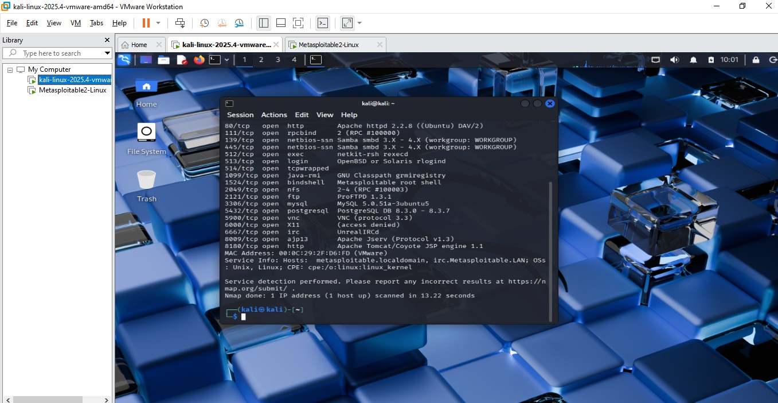

Figure 1: Nmap Scan Showing Open Ports and Services

Nikto Web Vulnerability Scanner

Nikto is an open-source web server scanner used to detect vulnerabilities in web applications.

Working:
It scans web servers for outdated software, dangerous files, and misconfigurations.

Command Used:
nikto -h http://192.168.154.129

Findings:
- Outdated Apache server
- Exposed phpinfo file
- Directory indexing enabled

Security Risk:
These vulnerabilities can expose sensitive information and allow attackers to exploit the system.

Example:
An exposed phpinfo file can reveal server configuration details which can be used for further attacks.
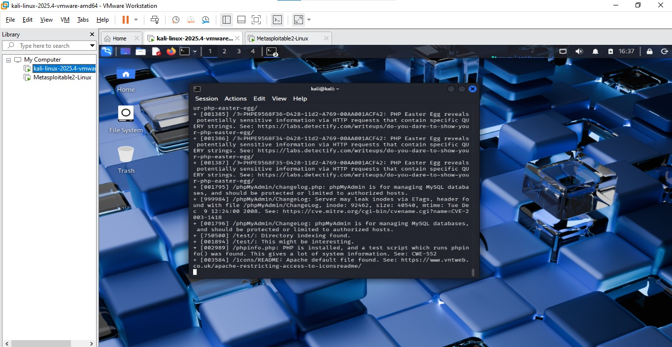

Figure 2: Nikto Scan Showing Web Vulnerabilities

Exploitation Phase

Metasploit Framework was used to exploit vulnerabilities identified during scanning.

Initial attempt using vsftpd backdoor exploit failed to create a session.

An alternative exploit (Samba usermap script) was used successfully.

Command Used:
use exploit/multi/samba/usermap_script
set RHOSTS 192.168.154.129
exploit

Result:
A command shell session was successfully opened.

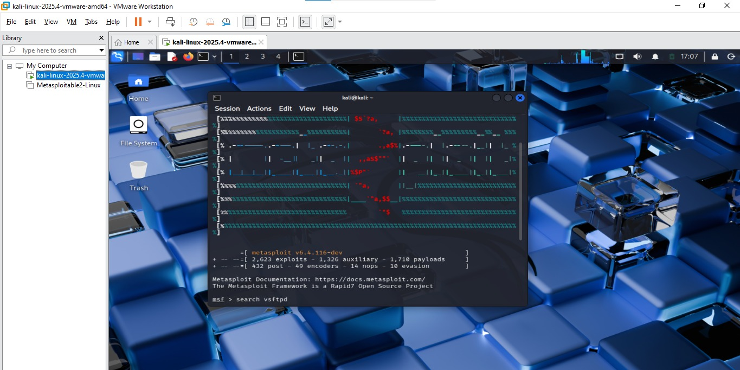

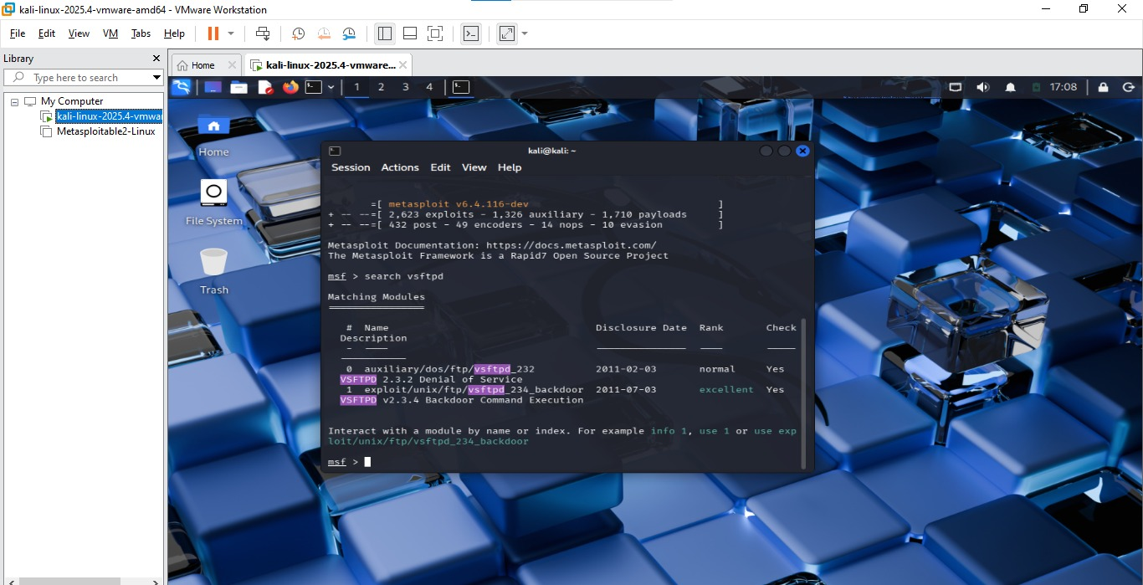
Figure 3: Metasploit Exploitation Showing Session Opened
Post-Exploitation Phase

The post-exploitation phase focuses on analyzing the compromised system, gathering information, and assessing the extent of access gained.

After successful exploitation, a command shell session was accessed using the Metasploit sessions command. Various system-level commands were executed to verify access and collect information.

Commands Used:
sessions -i 1
whoami
uname -a
ifconfig

The 'whoami' command confirmed root-level access, indicating full system compromise. The 'uname -a' command provided details about the operating system, while 'ifconfig' displayed network configuration information.

Additionally, a sample file was created and hashed using the SHA-256 algorithm to demonstrate evidence collection and data integrity verification.

Command:
echo "test" > file.txt
sha256sum file.txt
This phase highlights the potential impact of exploitation, where attackers can access sensitive system data and maintain control over the compromised machine.

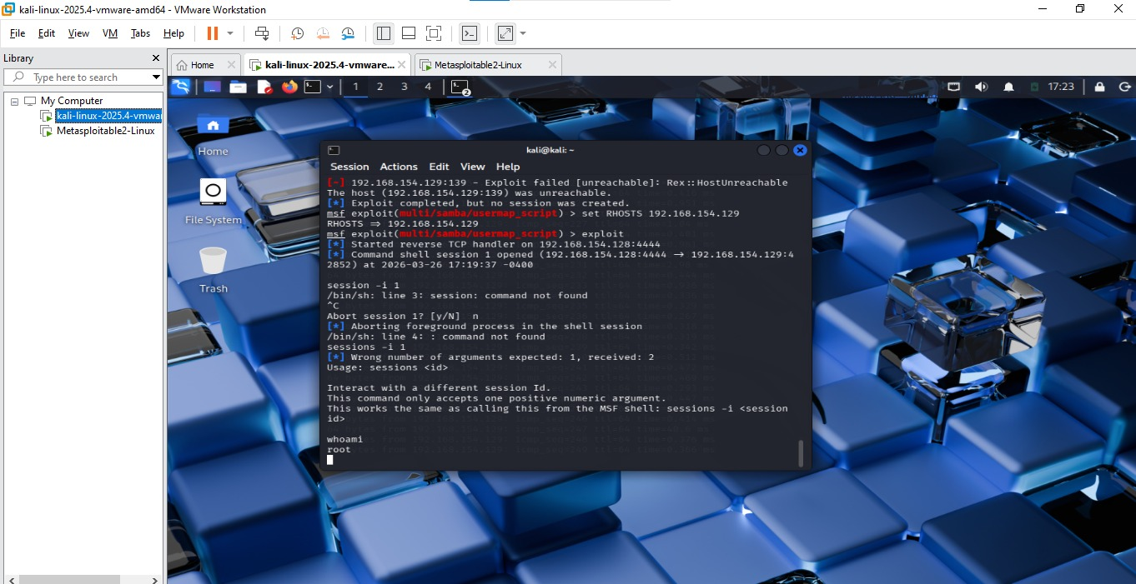

Figure 4: Post-Exploitation Showing Root Access and System Information

Evidence Collection

After gaining access to the target system, evidence collection was performed to demonstrate data integrity and validate post-exploitation activities.

A sample file was created on the compromised system and hashed using the SHA-256 algorithm. Hashing ensures that the data remains unchanged and can be verified later.

Commands Used:
echo "test" > file.txt
sha256sum file.txt

The generated hash value acts as a digital fingerprint of the file and is commonly used in forensic analysis.

This step highlights how attackers or analysts can collect and verify data during post-exploitation.

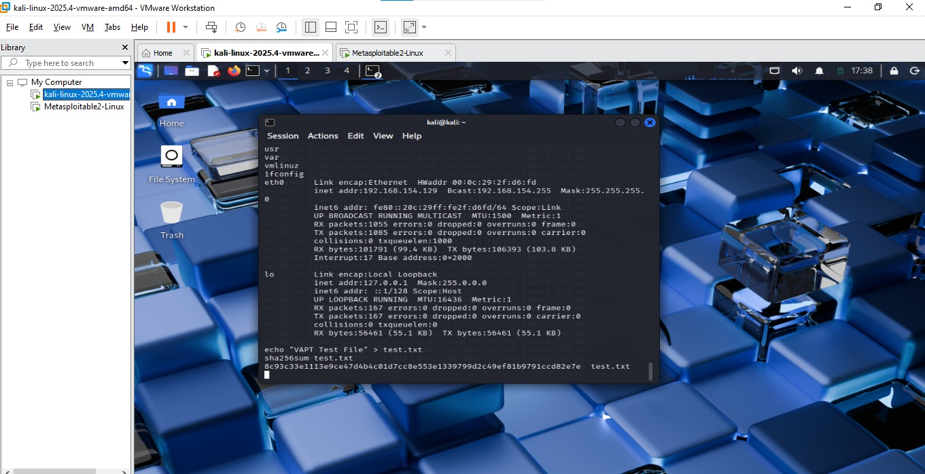
Figure 5: SHA-256 Hash Generation for Evidence Verification

Vulnerability Analysis

The scanning and exploitation phases revealed several vulnerabilities in the target system.

1. Open Ports (FTP, SSH, HTTP)
Risk Level: Medium
CVSS Score: 5.3
These services increase the attack surface and may be exploited if misconfigured.

2. Outdated Apache Server
Risk Level: High
CVSS Score: 8.1
Outdated software may contain known vulnerabilities that can lead to remote code execution.

3. Samba Usermap Script Vulnerability
Risk Level: Critical
CVSS Score: 9.0
This vulnerability allows attackers to execute commands remotely and gain root access.

The analysis shows that the system is highly vulnerable due to outdated services and weak configurations.

Risk Assessment

The identified vulnerabilities were evaluated based on their likelihood of exploitation and potential impact on the system.

High Risk:
- Samba vulnerability (full system compromise possible)

Medium Risk:
- Open ports (increased exposure)

Low Risk:
- Information disclosure issues

Risk evaluation was performed using qualitative analysis, considering both the severity of the vulnerability and its exploitability.

High-risk vulnerabilities require immediate attention, while medium and low risks should be addressed through regular security improvements.

Remediation

To improve the security posture of the system, the following remediation steps are recommended:

- Update all outdated services, especially Samba and Apache
- Disable unnecessary ports and services
- Apply security patches regularly
- Configure firewall rules to restrict access
- Implement strong authentication mechanisms

Regular vulnerability assessments and system monitoring should also be performed to detect and prevent future attacks.

Conclusion

The VAPT assessment successfully identified and exploited critical vulnerabilities in the target system. The exploitation phase demonstrated how attackers can gain unauthorized access, while post-exploitation activities confirmed full system compromise.

The findings highlight the importance of maintaining updated systems, secure configurations, and regular security testing. Implementing the recommended remediation measures will significantly improve the system’s security and reduce the risk of attacks.

